**Cloud Watch**

**EC2 Default Metrics**

**Instance:**

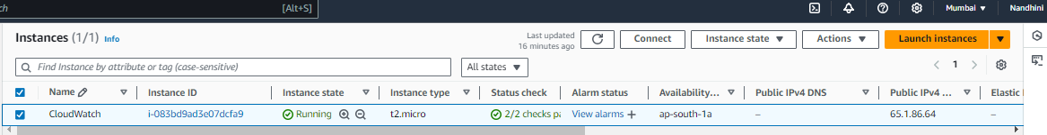

**Jenkins Deployed:**

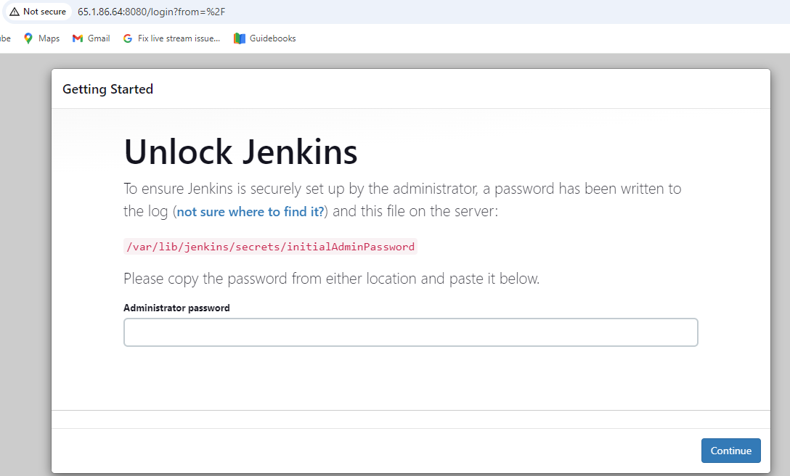

**EC2 DEFAULT METRICS:**

**CPU UTILIZATION:**

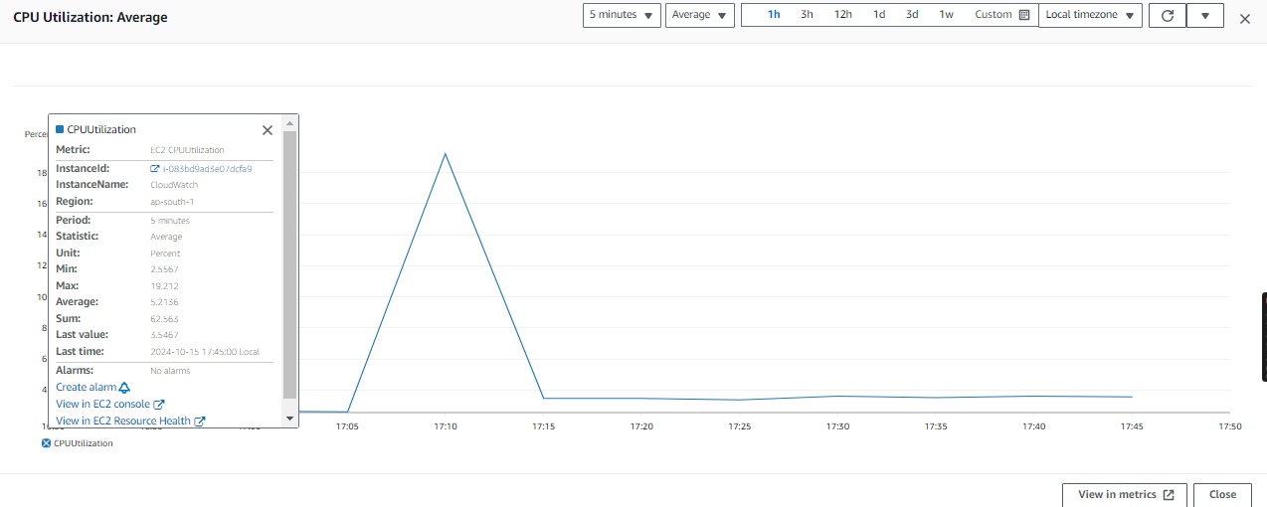

**Network Out: Bytes**

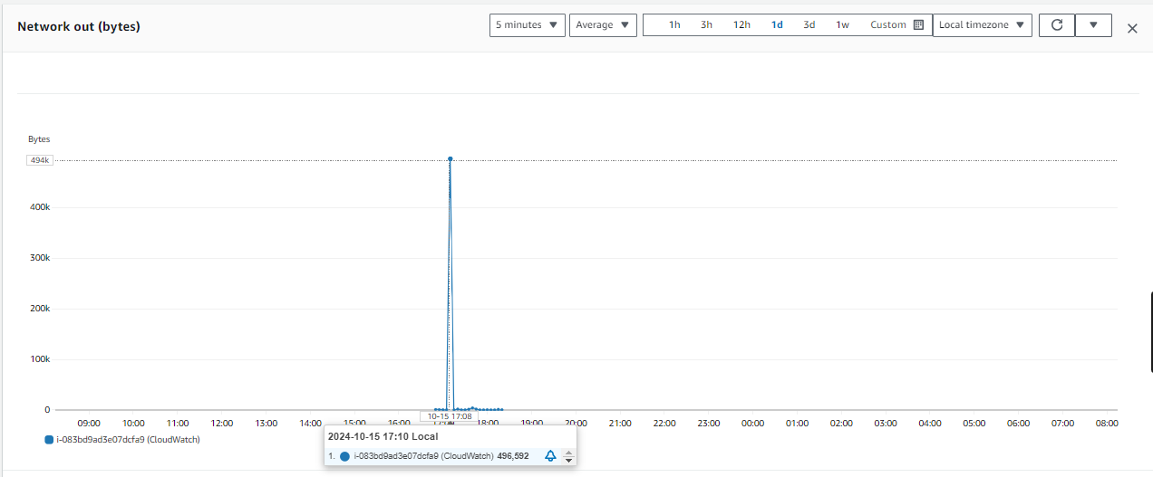

**Network In: Average**

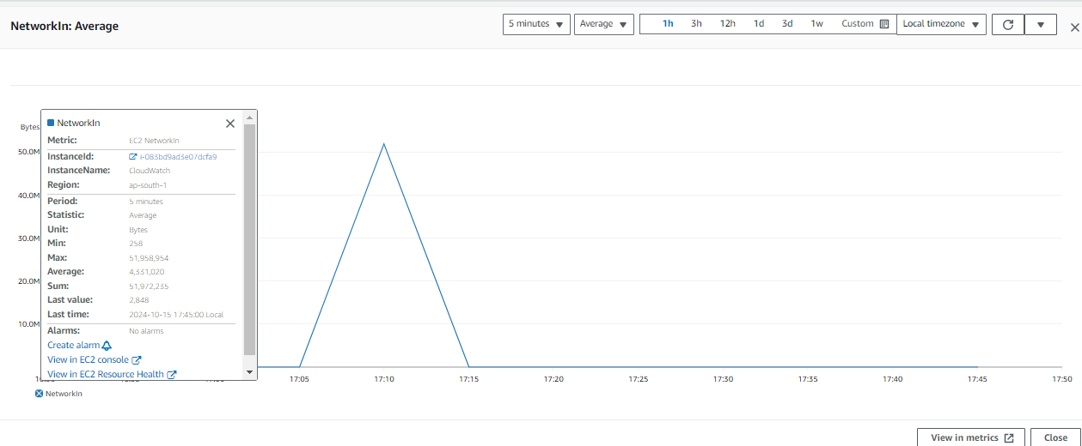

**CPU credit balance (count):**

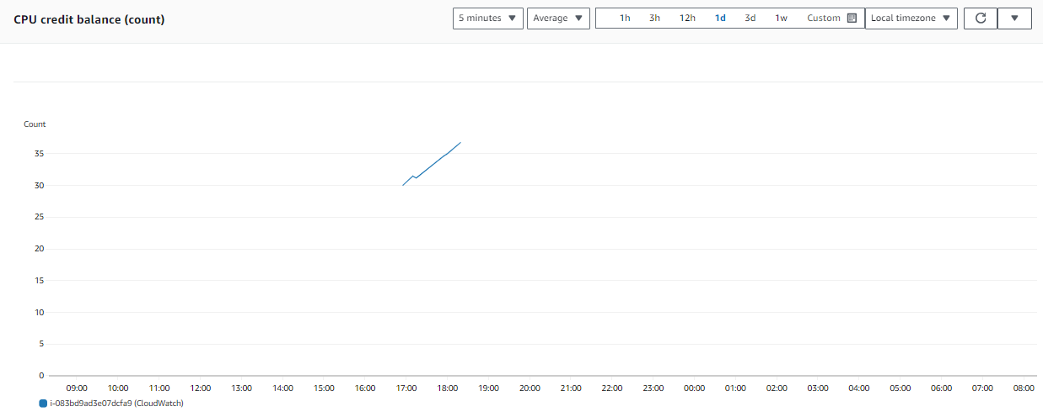

**CPU credit usage (count):**

